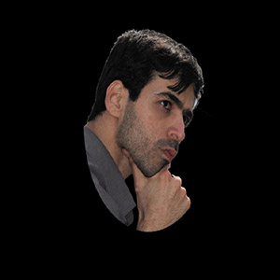 |  |  |  | DAVOOD JAVADI  Back-End Developer (laravel)

Skills
• Html – css – Javascript [bootsrap – jquery – vue]
• PHP [laravel - wordpress]
• Api – Mysql – Git
• Seo

Experienced
Develop Projects:
- Shop, Corporate, Multilanguage, B2B, Personal, Beauty, Educational and…

Records
I have been working in this position for five years and in these years I have done various projects for several companies as a programmer and I have also developed freelance projects.

Also, the support of the projects carried out now continues.

Languages
• Parsian
• English
• Turkish

 |  | Tehran - Iran
 |  | 98 919 96 89 260
 |  | Javadi.davood@gmail.com
 |  | davoodjavadi.ir

